

TEMENOS T24

Stream

User Guide



Edge Feed – RSS Feed and Code

Table of Contents

Introduction 3

Preface 3

Overview 3

Assumptions 3

Getting Started 3

Installation 3

Adding Edge RSS Feed Widget 4

# 

# Introduction

## Preface

This User Guide is intended for Developers and provides the step by step instructions for adding an Edge RSS Feed widget, in your presentation.

## Overview

Edge Feed – RSS Feed is a widget for parsing and displaying RSS and Atom feeds. This widget uses [Google Feed API](https://developers.google.com/feed/) to retrieve feeds. You can obtain feeds easily from any domain. There is no need for server-side scripts.

## Assumptions

It is assumed that you are familiar with the edgeConnect Editors and have working knowledge on edgeConnect.

# Getting Started

## Installation

For manual installation:

1. Copy **com.temenos.widgets.feed.RSS** folder in your widgets folder (Ex: /{your project/templates }).
2. Restart IDE.

For auto-installation:

1. Run IDE.
2. Make sure the ‘**Switch Monitor on/off**’ is checked.
3. Download or copy the widget **com.temenos.widgets.feed.RSS.zip** to the monitored folder.

(Navigate to **Tools** -> **Options** -> **Auto-install** tab and set in **Download Location**, the folder where you copied the widgets) There is no need to restart IDE.

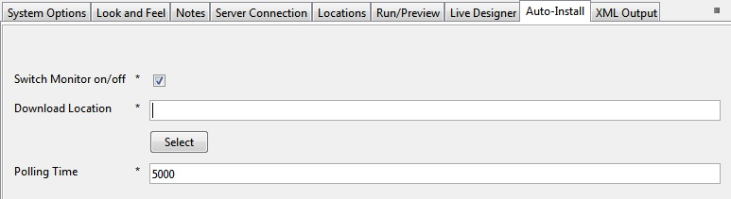

## Adding Edge RSS Feed Widget

To add an Edge RSS Feed widget:

1. You will have to insert a new display Item of **Edge Feed** type, in the **Presentation Editor**.
2. Within **Widget Details** tab, you have to set up the following widget settings.

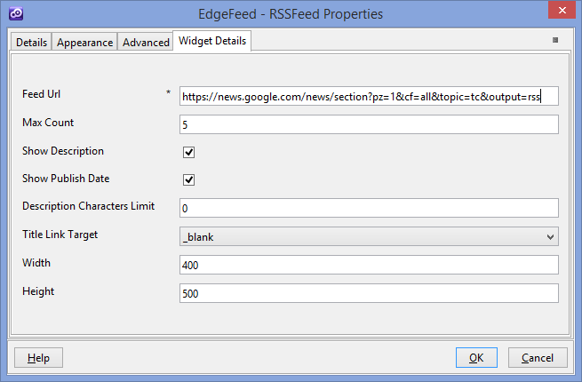

* **Feed Url** – the URL for the feed.
* **Max count** - the feed Items count that will be displayed within the widget.
* **Show Description** - option to show the description of the feed Item
* **Show Publish Date -** option to show the publish date of the feed Item
* **Description Characters Limit -** Feed Description Characters Limit Count. 0 means no limit. Indicates the number of characters from the feed item content that will be displayed.
* **Title Link Target -** [The target attribute](http://www.w3schools.com/tags/att_a_target.asp) specifies where to open the linked document.
* **Width­** – The width of the feed container.
* **Height** – The height of the feed container.